HttpClient

យើងគិតវាដូចជា Webrower ដែលធ្វើការ Request to the Server
HttpClient is a tool (class/library) in Java used to send HTTP requests and receive responses from a server (like APIs or websites).

👉 In simple words:
It helps your Java program talk to the internet.
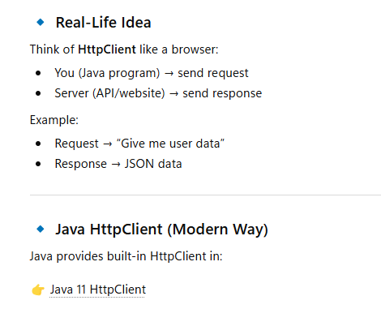

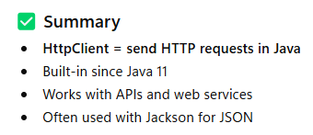

- Create HttpClient
Create Server from the jwebserver in java to provide the Server
>> jwebserver
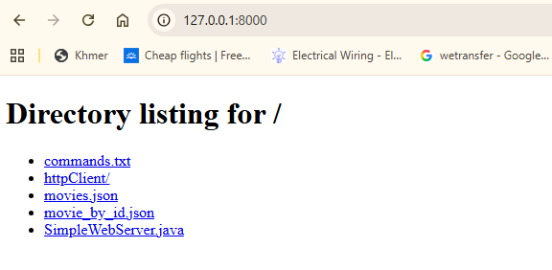

We have two Json uri :

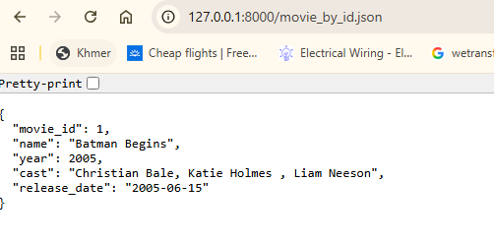

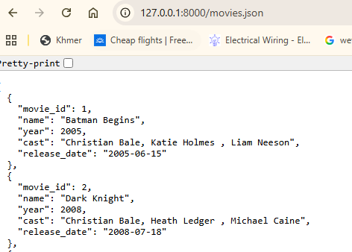

ចឹងយើងចង់ពេលដែលធ្វើការ Request to the URL above it will return to us in the Object in JAVA

- In the java we create record : Movie.class (object that store the JSON file from request url

package com.learn.java.date.java18.httpClient;

import java.time.LocalDate;

public record Movie(
Double movie_id,
String name,
String cast,
Integer year,
LocalDate release_date
) {

}

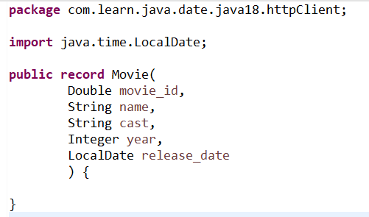
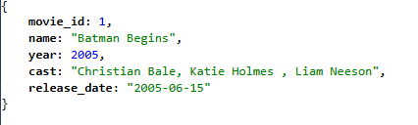

- MoviesClient.java (it is the logic that we request to the url)
Step by Step note:
- Create End Point Request URL
- Create request (URL) and respond (Java Object)

3.1- GetMovieByID
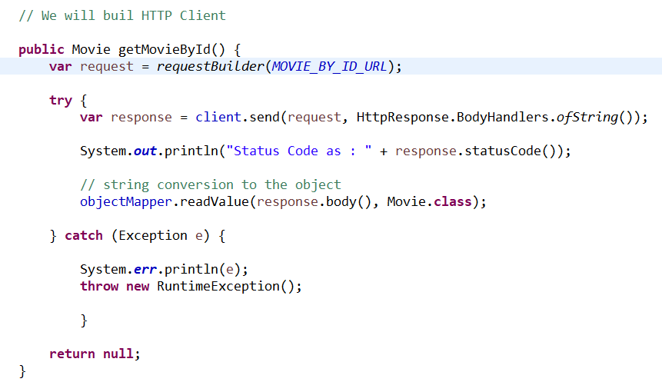

- Create function to put URL then we the response: HttpRequest
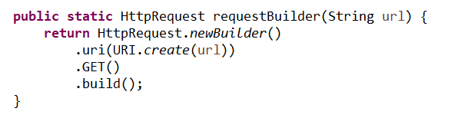

3-2 Create Http Client
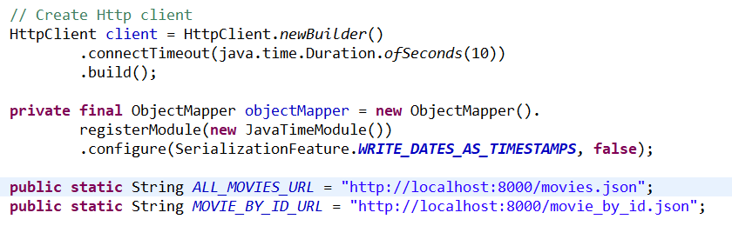

- Dependany to serialife and disarerial live

<!-- For LocalDate / LocalDateTime support -->
<dependency>
<groupId>com.fasterxml.jackson.datatype</groupId>
<artifactId>jackson-datatype-jsr310</artifactId>
</dependency>

